# Lab 06: Reusing, Installing, and Configuring Additional Components

**Lab Overview:** In this lab you are going to implement all of the new ideas you have learned in the lecture.

## Exercise 1: Site Templates

In this exercise you will create a New Customer site for the sales team. You will set the site up with the standard files used in setting up a new customer. Once, you complete the site setup you will save it as a template and make it reusable. Finally, you will make the site available globally by using stsadm.

1. Open the Sales site
   1. Navigate to **http://portal.tpg.local**
   2. Login as **tpg\alan**
   3. Hover over **Departments** and click **Sales**
2. Create a New Customer Template site
   1. Click Site Actions > **Create Site**
   2. Title = **New Customer Template**
   3. URL = **/new**
   4. Template = **Team Site**
   5. Navigation Inheritance = **Yes**
   6. Click **Create**
3. Add Necessary Documents
   1. Click **Shared Documents**
   2. Click **Upload Multiple Documents**
   3. Navigate to **c:\_Student Files\Module 6**
   4. Select **all files**
   5. Click **OK**
   6. Click **Yes**
4. Add Shared Documents to home page
   1. Click **New Customer Template** in the breadcrumb
   2. Click Site Actions > **Edit Page**
   3. Click **Add a Web Part** in the **Left** zone
   4. Select **Shared Documents** and click **Add**
   5. Click **Exit Edit Mode**
5. Change the theme
   1. Click Site Actions > **Site Settings**
   2. Under Look and Feel click **Site Theme**
   3. Select a different theme and click **Apply**
6. Save Site as template
   1. From the Site Settings screen under Look and Feel click **Save site as template**
   2. Filename = **NewCustomer**
   3. Template name = **New Customer Template**
   4. Select **Include Content**
   5. Click **OK**
7. At Operation Completed Successfully click **OK**
8. Click **Sales** from the Global Nav
9. Create a new site using the Template
   1. Click Site Actions > **Create Site**
   2. Title = **Acme Corp**
   3. URL = **/acme**
   4. Select a template = **Custom** tab, **New Customer Template**
   5. Navigation inheritance = **Yes**
   6. Click **Create**

Notice your Shared Documents are ready to go including the Web Part on the page. Also, your pretty theme is still intact.

## Exercise 2: Using the template globally

If you were to navigate to the HR Private Site and tried to create a site using the New Customer Template it would not be an option. This is because when you saved the site as template you saved it to the site collection template gallery and HR Private is in a different site collection. In order for the template to be usable in the HR Private site collection you need to deploy the template using stsadm.

1. Make sure the template is not available in the HR Private site
   1. Navigate to **http://portal.tpg.local/sites/hr**
   2. Login as **tpg\betsy**
   3. Click Site Actions > **Create**
   4. Under Web Pages select **Sites and Workspaces**
   5. Look at Select a template. Notice there is no custom tab available.
2. Download the template
   1. Navigate back to **http://portal.tpg.local**
   2. Sign in as **tpg\alan**
   3. Click Site Actions > Site Settings > **Modify All Site Settings**
   4. Under Galleries click **Site templates**
   5. Click on **NewCustomer**
   6. Click **Save**
   7. Save it to **c:\newcustomer.stp**
3. Load the template globally
   1. Open the **command prompt**
   2. Navigate to **c:\program files\common files\Microsoft shared\web server extensions\12\bin**
   3. Run the command

Stsadm –o addtemplate –filename c:\newcustomer.stp –title “New Customer Template”

* 1. Run the command

IISreset.exe

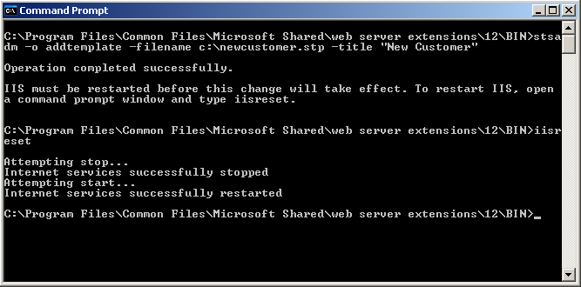

* 1. Leave the command prompt open. You will use it later in the lab.

1. Navigate back to HR Site to check out the results
   1. Navigate to **http://portal.tpg.local/sites/hr**
   2. Login as **tpg\betsy**
   3. Click Site Actions > **Create**
   4. Under Web Pages select **Sites and Workspaces**
   5. Look at Select a template. Notice there is now a custom tab. And on the tab is New Customer template.

## Exercise 3: Add a feature

Your developers have just given you the files to deploy their new feature. They didn’t have time to package it properly so you will have to deploy it manually.

1. Copy the files into place
   1. Open My Computer and navigate to **c:\_student files\module 6**
   2. Copy the **HelloWorld** folder
   3. Open another instance of My Computer and navigate to **c:\program files\common files\Microsoft shared\web server extensions\12\template\features**
   4. Paste in the **HelloWorld** folder
2. Open the **command prompt**
3. Navigate back to **12\bin** so you can run Stsadm
4. Run the command

Stsadm –o installfeature –name HelloWorld -force

1. Run the command

Stsadm –o activatefeature –name HelloWorld –url http://portal.tpg.local -force

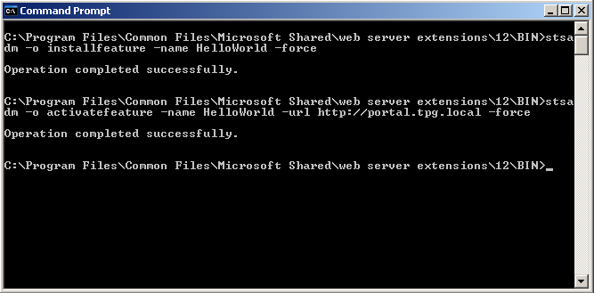

1. Leave the command prompt open, you will be using it again.
2. Open **http://portal.tpg.local**
3. Sign in as **tpg\alan**
4. Click **Site Actions**
5. At the bottom of the menu you can see the new feature Hello World. If you click it you will be taken to the MSDN site.

You will also notice that if you went back to http://portal.tpg.local/sites/hr or to http://portal.tpg.local/departments you would not see the menu. This feature was deployed only to the http://portal.tpg.local site because it is scoped at the web level. You could deploy it to another site by rerunning the command and specifying the URL or using the web interface.

1. Add the feature to the Departments site using the web interface
   1. Navigate to **http://portal.tpg.local/departments**
   2. Click Site Actions > Site Settings > **Modify All Site Settings**
   3. Under Site Administration click **Site features**
   4. You should see **A Sample Feature: Hello World** click **Activate**
   5. Now click **Site Actions** and notice Hello World is available

## Exercise 4: Deploy a WSS Solution Pack

1. Open **http://portal.tpg.local** with **FireFox** located on your desktop as **tpg\alan** to discover why you need the RAD Editor
2. Create a Wiki site
   1. Click Site Actions > **Create Site**
   2. Title = **Wiki**
   3. URL = **/wiki**
   4. Template = **Wiki Site**
   5. Click **Create**
3. Click **Edit** from the right side of the page

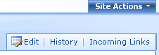

1. You see nothing but raw HTML

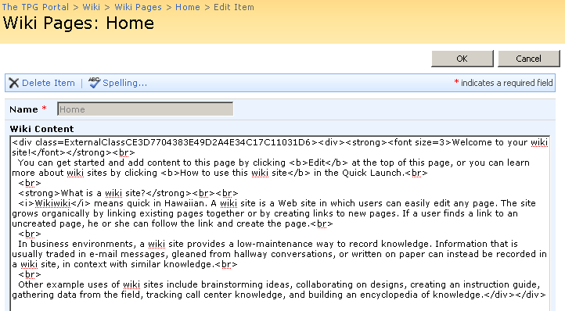

Compare that to what it would look like if you opened the page with Internet Explorer.

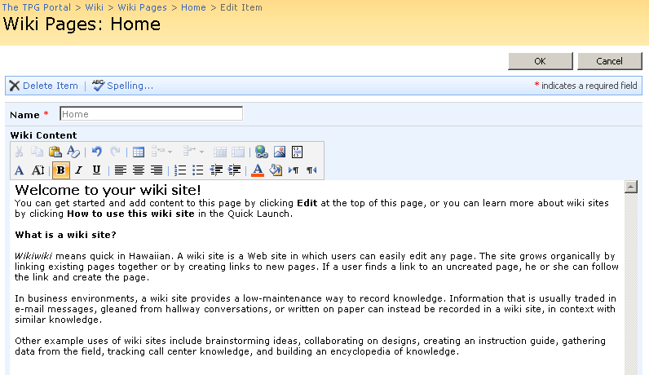

1. Install the RAD Editor WSS Solution Package
   1. Open a **command prompt**
   2. Navigate back to **12\bin** so you can run Stsadm
   3. Run the command

Stsadm –o addsolution –filename “C:\_student files\mo

dule 6\rad editor\radeditormoss.wsp”

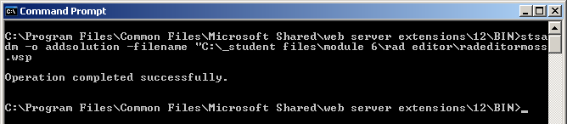

* 1. Leave the command prompt open.

1. Deploy the solution using Central Admin
   1. Click Start > **SharePoint 3.0 Central Administration**
   2. Click **Operations** tab
   3. Under Global Configuration click **Solution management**
   4. Click **radeditormoss.wsp**
   5. Click **Deploy Solution**
   6. Now select **http://portal.tpg.local** for Deploy To?
   7. Click **OK**

Had you left Deploy To? You would have deployed the Web Part to the GAC. Giving the solution Full Control. Never a good idea especially when installing 3rd party solutions.

If you opened up the web.config located at C:\inetpub\wwwroot\wss\virtualdirectories\portal.tpg.local80 you would see there are now SafeControl entries for the RAD components.

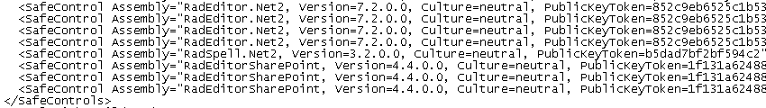

1. Go back to **FireFox** and check your page
   1. Go to **http://portal.tpg.local/wiki**
   2. Click **Edit**
   3. Still the same problem. This is because you have not activated the Feature that the solution packaged deployed.
2. Activate the Feature
   1. Click Site Actions > **Site Settings**
   2. Under Site Administration click **Site Features**
   3. Next to **Use RadEditor to edit List Items** click **Activate**
3. Try to edit the page again
   1. Click **Wiki** in Global Nav
   2. Click **Edit** button
   3. Still the same problem. What now? You have just discovered one of the challenges of using a truly secure install. When you activated the feature the first time it attempted to copy ..12\template\features\RadEditorFeature\RadEditorList.ascx to ..12\template\ControlTemplates\RadEditorList.ascx. You will need to now do this manually.
4. Copy the control into place
   1. Navigate to **c:\program files\common files\Microsoft Shared\web server extensions\12\Template\Features\RadEditorFeature**
   2. Copy **RadEdtiorList.ascx**
   3. Navigate to **c:\program files\common files\Microsoft Shared\web server extensions\12\Template\ControlTemplates**
   4. Paste **RadEditorList.ascx**
5. Open a **command prompt** and run

Iisreset.exe

1. Go back to **FireFox** and check your page
   1. Go to **http://portal.tpg.local/wiki**
   2. Click **Edit**

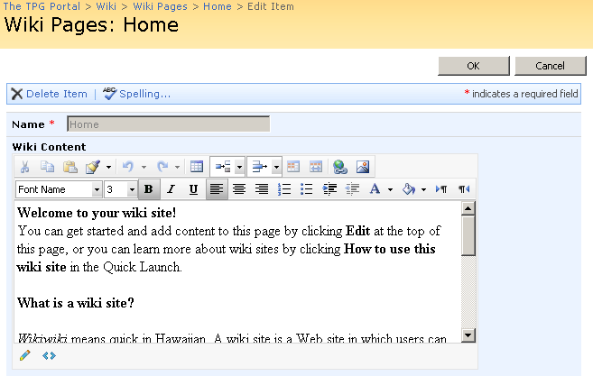

## End of Lab